**TANK Inc.**

Neo Thokoa u14163285

Keanan Jones u13036892

Takalani Sigama u14166365

Vincent Soweto u14137217

www.translux.co.za

IMY 310 FINAL DESIGN

Translux Website

# **Introduction**

This report demonstrates the functionality of our mock-up of the new and improved Translux’s site. This mockup can be found at the provided Translux folder. This report includes screenshots of the main pages of the sites as well as a demonstration of how to perform certain tasks specific to user needs.

# **Major Pages**

## Home

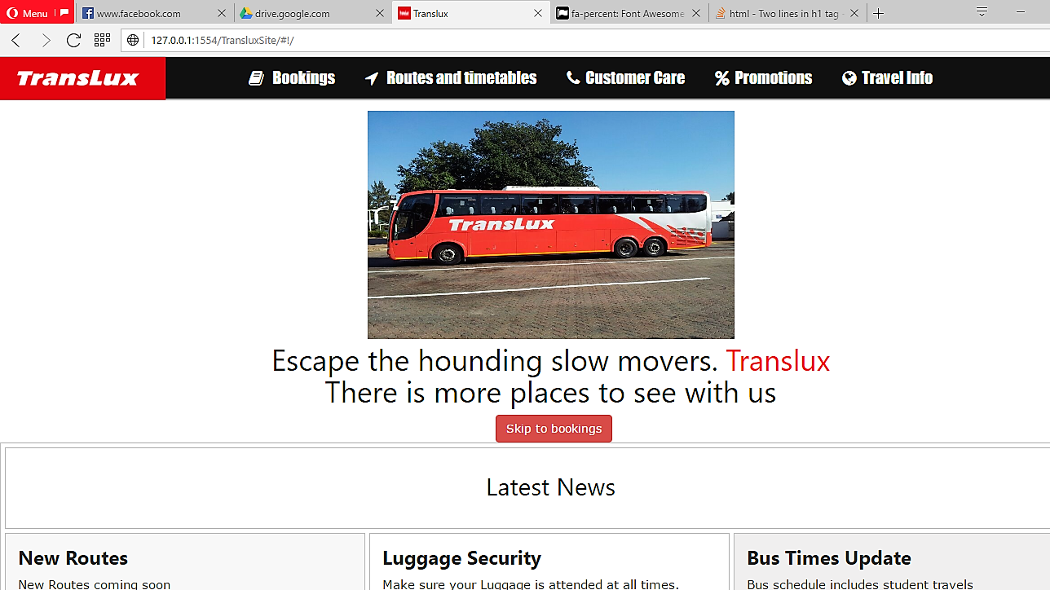

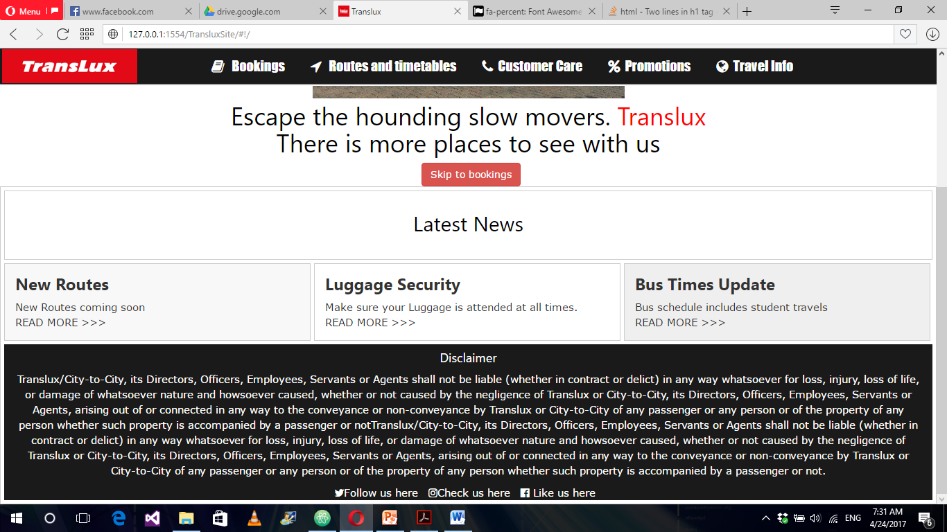

## Bookings

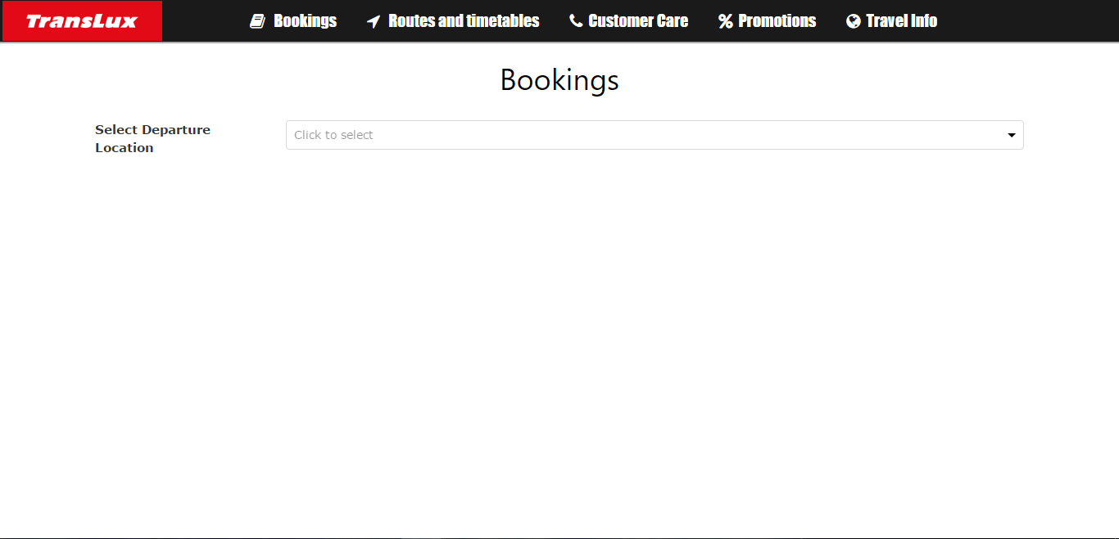

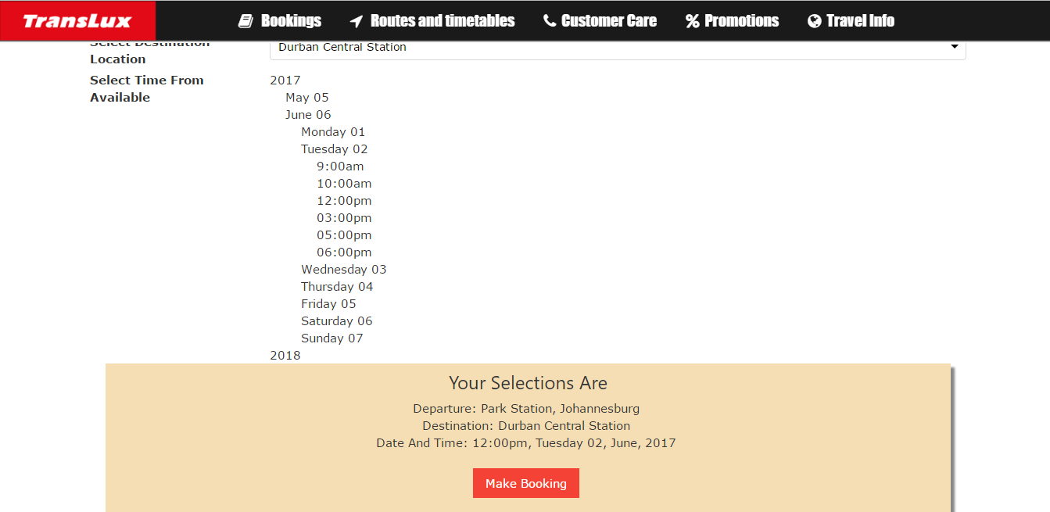

## Routes and Tables

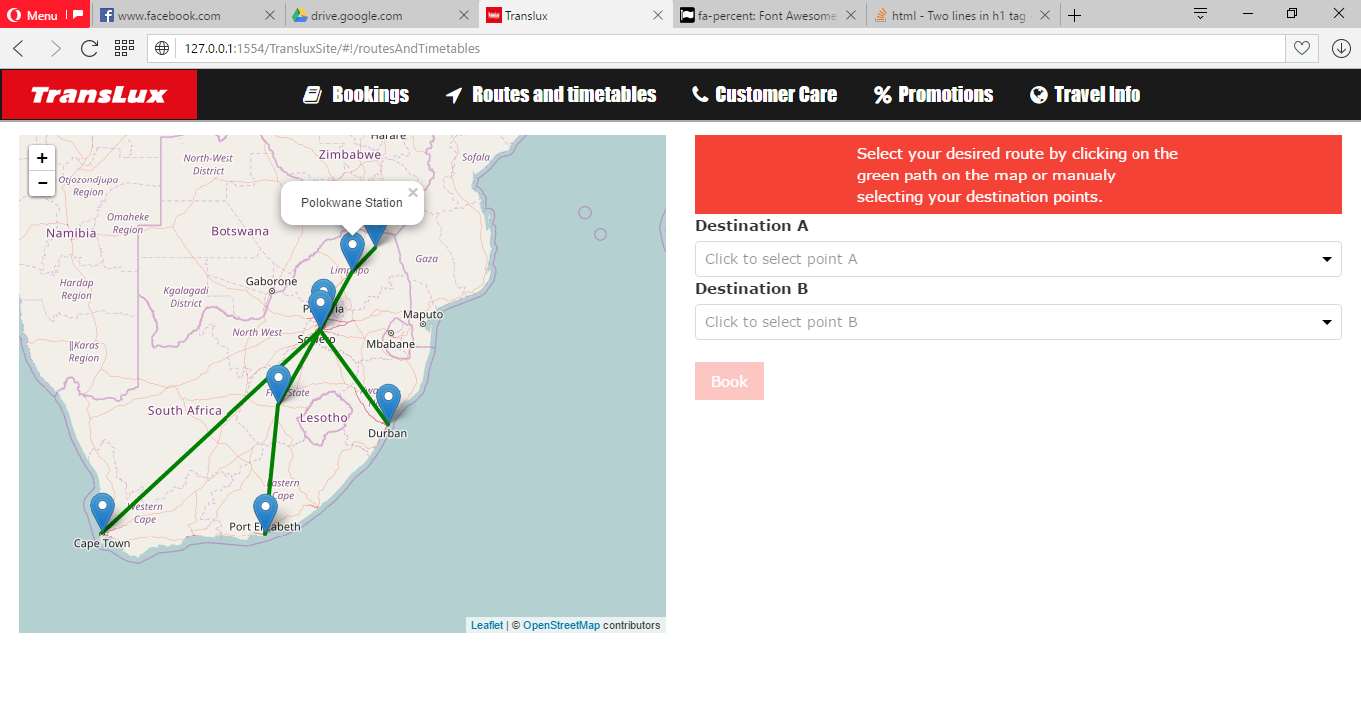

## Customer Care

## Promos

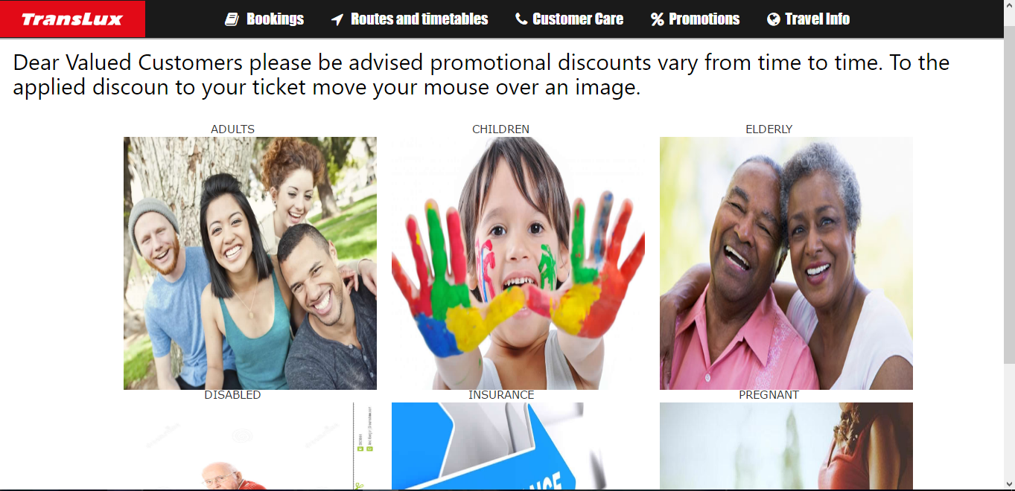

## Travel Information

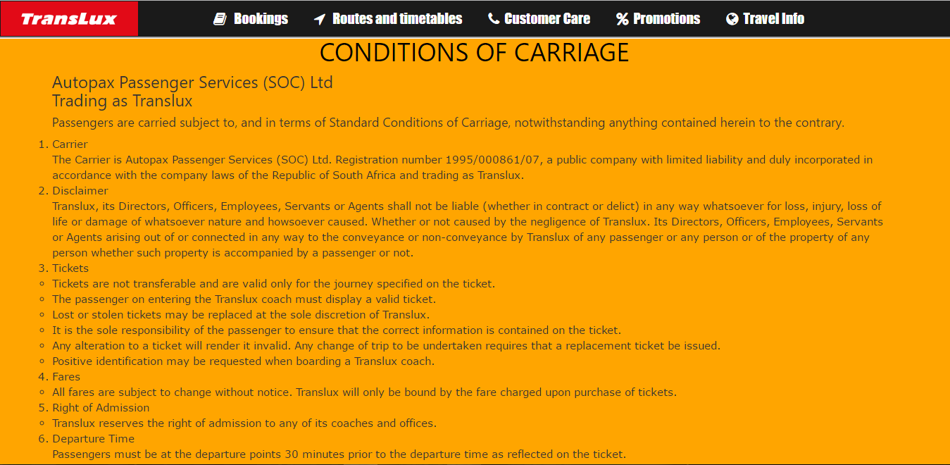

# **Tasks as per User Needs**

1. Finding information about home
2. User looking to Routes and Timetables from home
3. User looking to making way to booking on home
4. User making booking
5. Getting new Routes, Luggage Security and Bus Times Update about home
6. User utilizing routes on map
7. User looking to customer care
8. User looking at promos
9. User looking at travel information
10. User wanting to interact socially with Translux from home from any page

# **Completion of Tasks**

## Task 1: Finding information about home

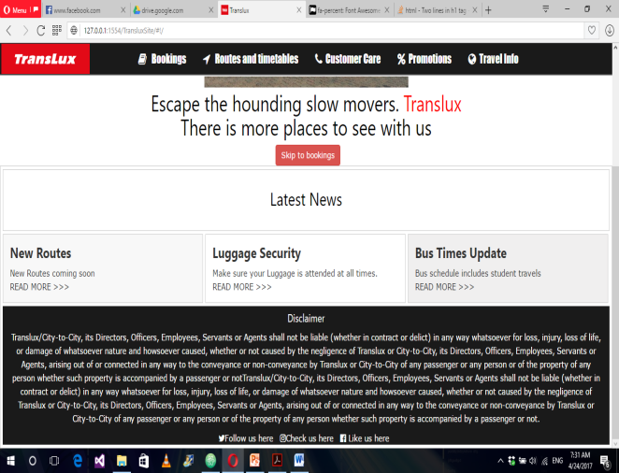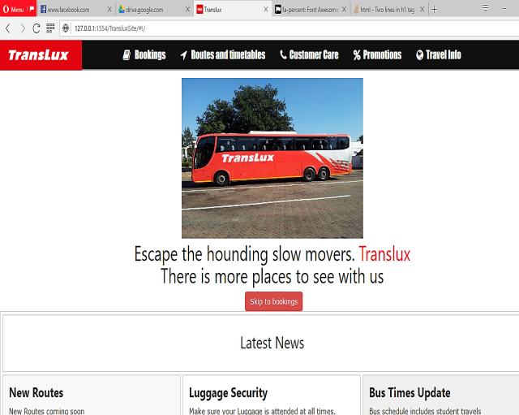**Demo:**

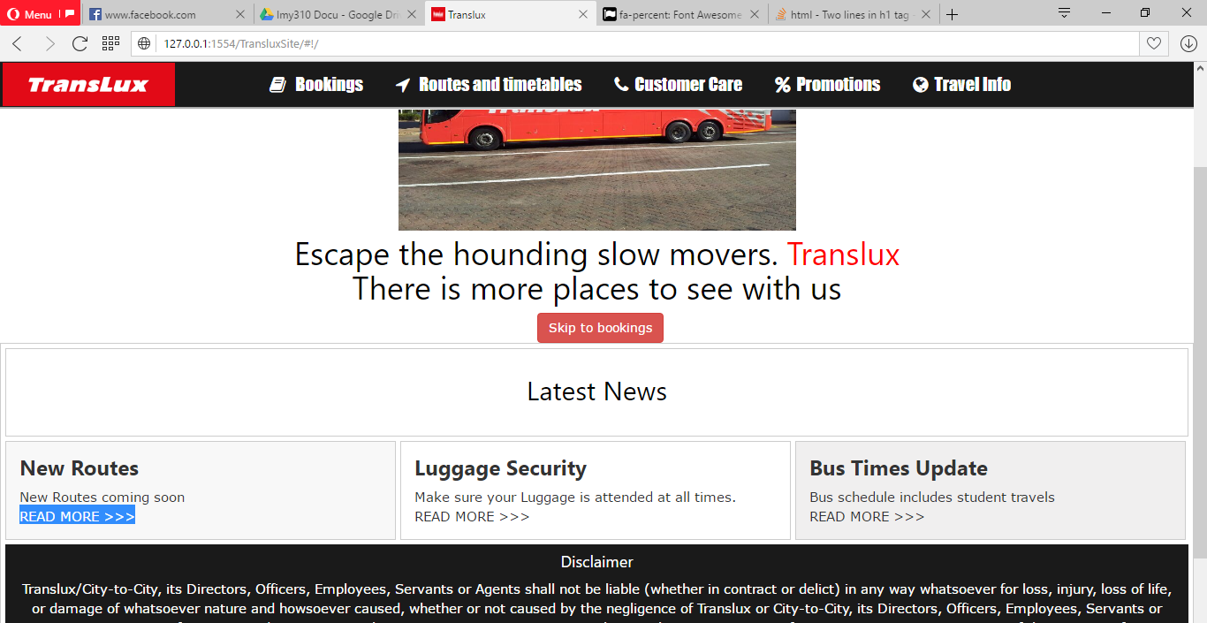

**Description:**

A user looking for information about the home, will enter the site and first encounter the home page where they will be able to see an image of the bus with the Translux label as well as the slogan. This is followed by a labeled bookings button that is center of the page to grab the users focus as this links to the main functionality of the Translux site. The user can then proceed to view more information about the site by scrolling downwards and checking out the latest news. Then the page concludes with a footer containing a disclaimer that is seen as the companies terms and conditions and so users (specifically users more concerned with the legal aspects of the site such as attorneys) fully understand the legal obligations between both parties. This highlights the need to get a basic idea of using an interface or bridge to address other needs as well as giving users information about the site.

## Task 2:

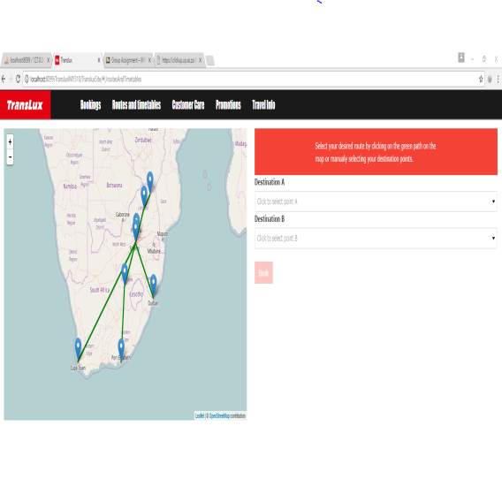**Demo:**

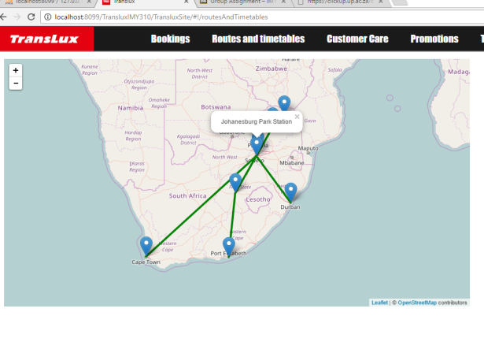

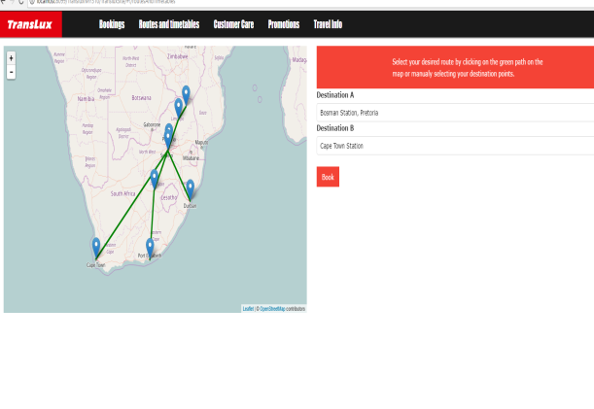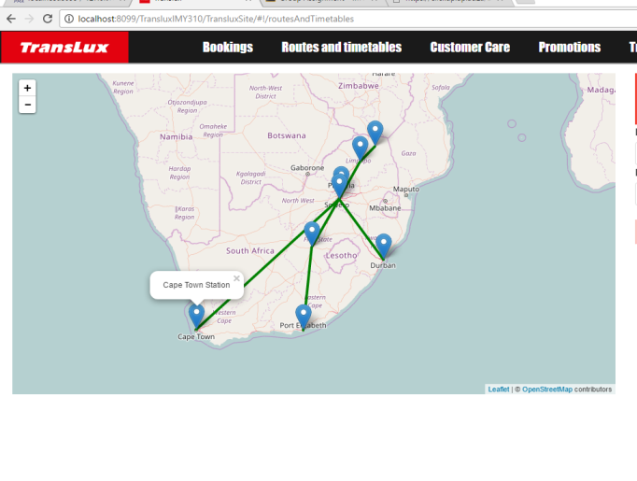

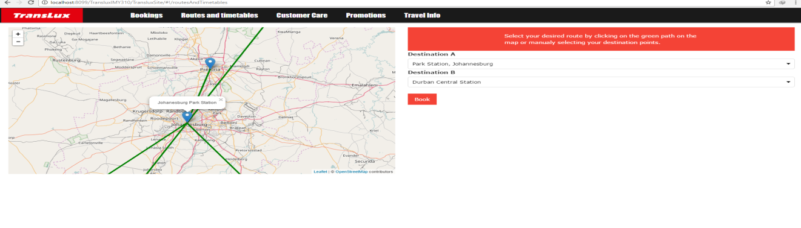

**Description:**

These Images are for navigating the map for available routes provided by the what was selected in the drop down lists of Destination A and B, then select a route with a destination then pressing the book button to book for the bus.

## Task 3:

**Demo:**

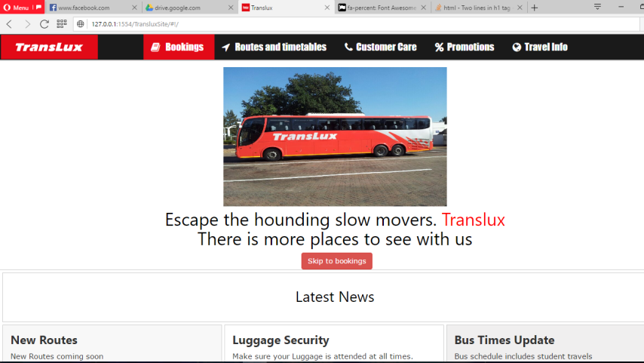

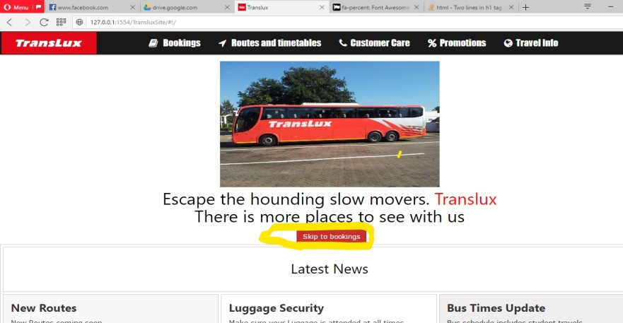**OR**

**Description:**

User can use navbar to navigate to various pages by clicking on the various links or by using the button on the home page. This is to eradicate the function on the original site where it automatically sends you to the booking page. And to address the need to get to the booking page in more than one way Specifically to specialized users such as promoters looking to showcase the functionality of the translux site. These are quickand easy to find links.

## Task 4:

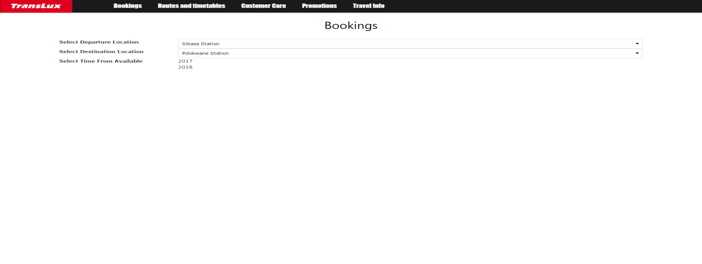**Demo:**

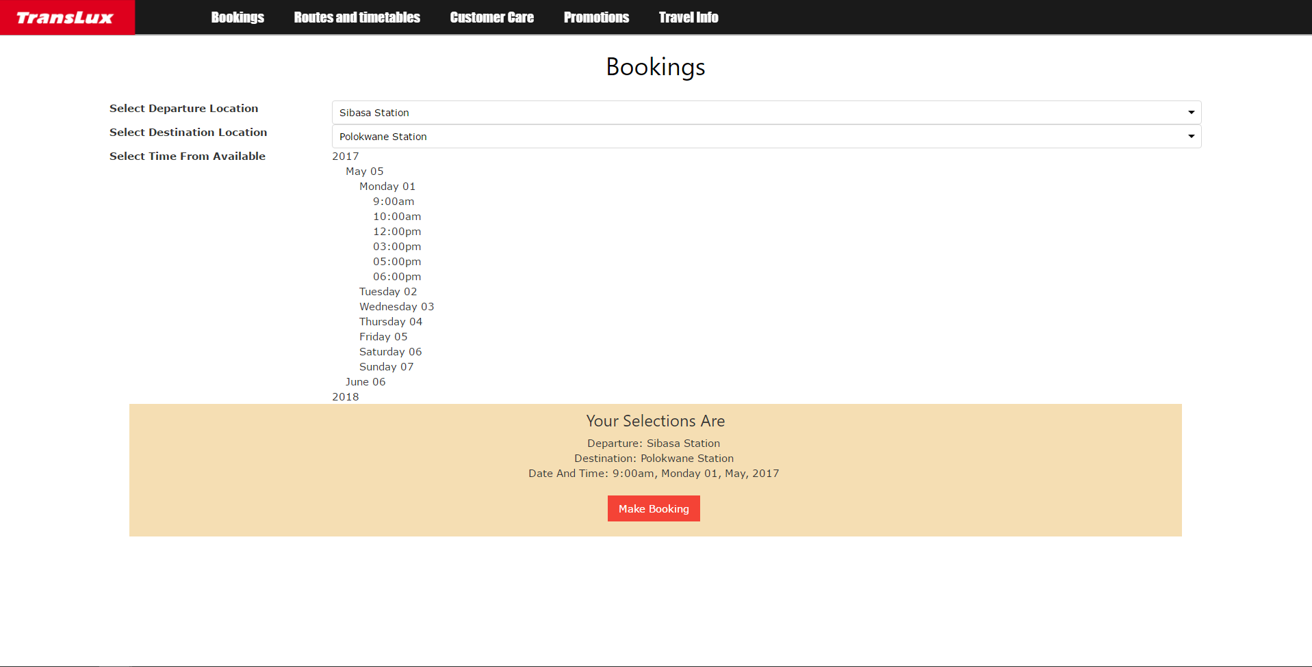

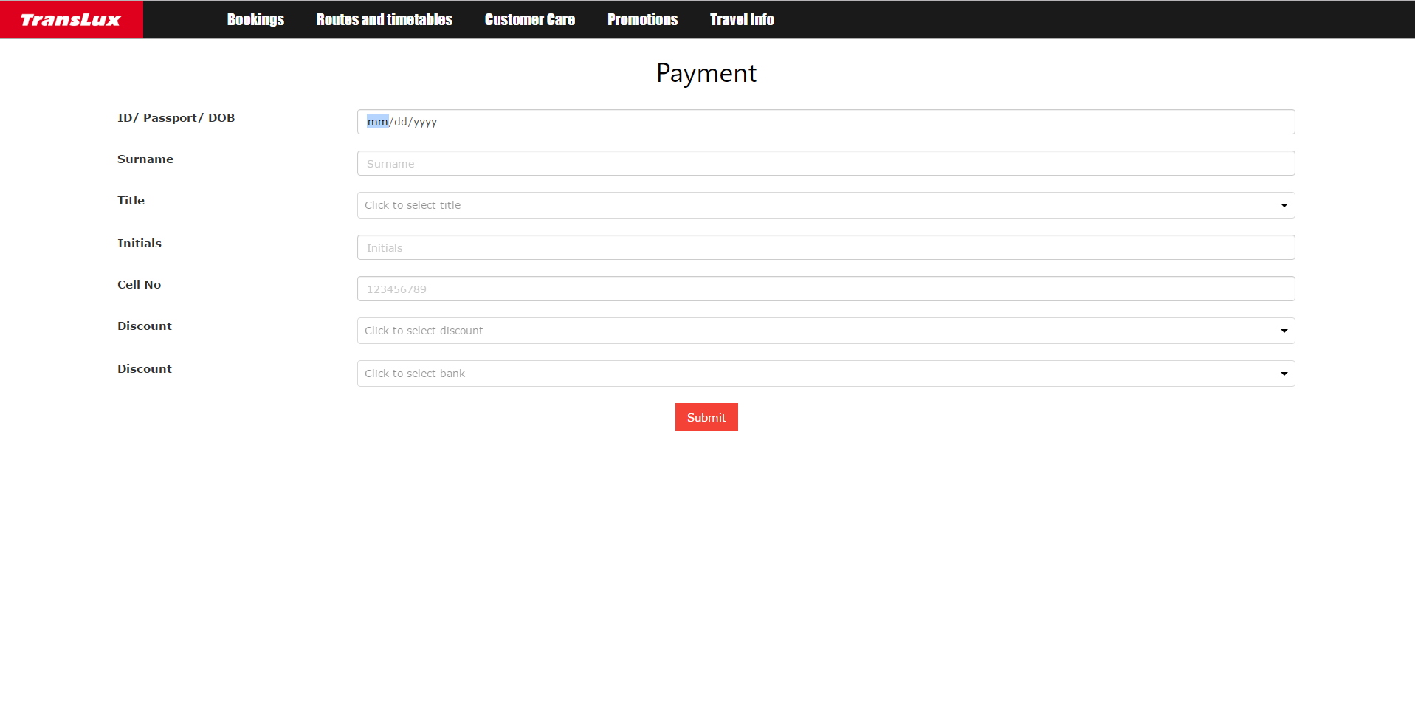

**Description:**

The above screen shots illustrate the booking process. Users select the relevant items as they are shown. The order of sections that show is based on each step. Stap 1 is selecting departure point. This means that other selections are hidden until this selection is made, then step 2 will show and so on. The available date selector allows the user to choose by year then month, day and time. Each selection further expands the selection tree. The user will then be presented with the options they have selected. Once they have made sure of their selections the user then clicks make payment and enters their details on that page and clicks submit. The user is then notified that an email consisting of the relevant information will be sent to them. They can then proceed to the home page or close the browser.

## Task 5:

**Demo:**

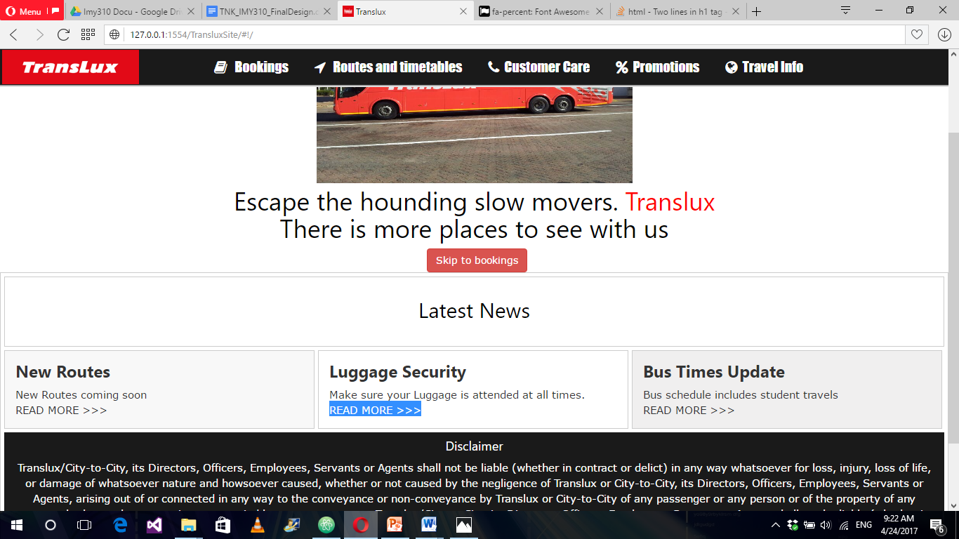

**Description:**

When user navigates to the article section on the home page, the user will find 3 sections, These Sections contain a brief description of what the rest of the column contains. When user clicks the READ More, that particular section expands which shows more content related to that section. By doing this it helps to not bombard the home page with too much information as some users are not interested in reading whereas it also addresses the need that users that like to keep up to date with news related to the section they interested then they can have the control to keep up-to-date. Users like journalists also have information to keep track of.

## Task 6:

**Demo:**

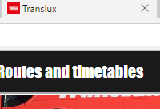

**Description:**

Even though this does not add any functionality, it still does address the need for a logo to be present on the tab such that users know where the Translux tab is particularly when multiple tabs are open. This addresses specific users that need imagery to navigate on the web such as Users that cannot read.

## Task 7:

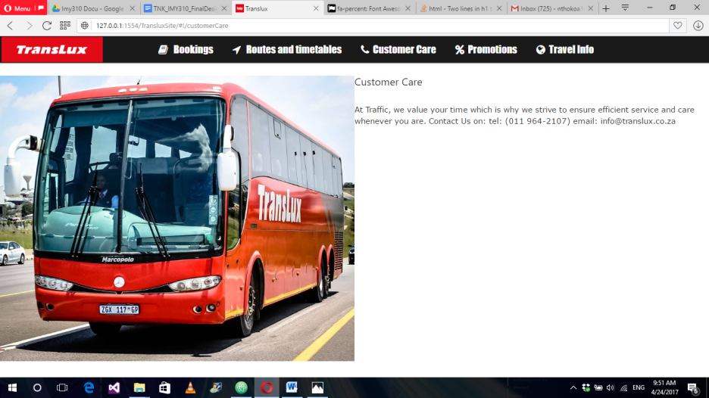**Demo:**

**Description:**

As users navigate to the customer care, they will find related content of Translux to satisfy the need to be able to reach out to them.

## Task 8:

**Demo:**

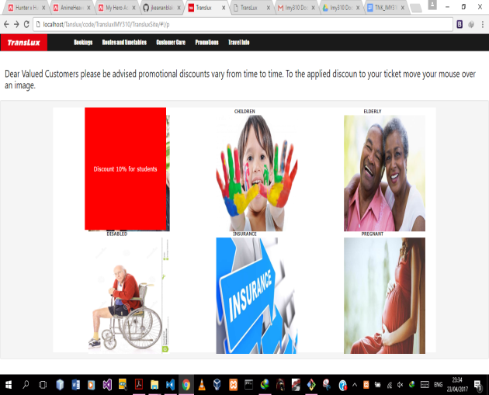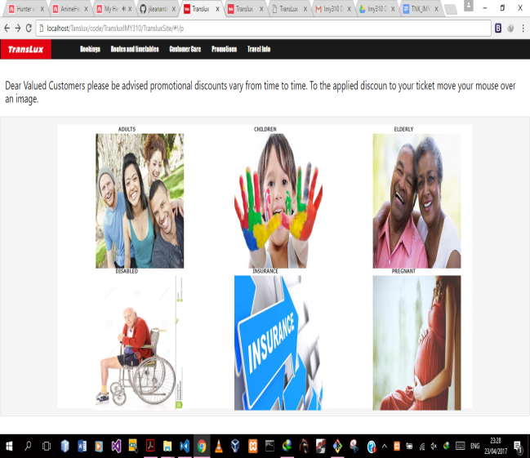

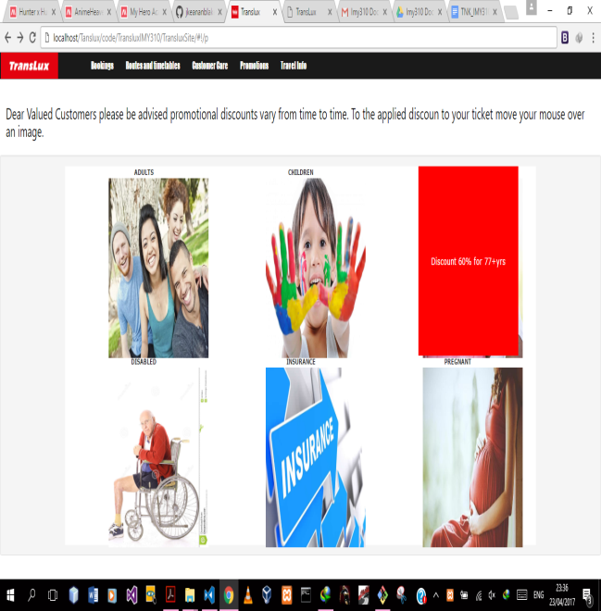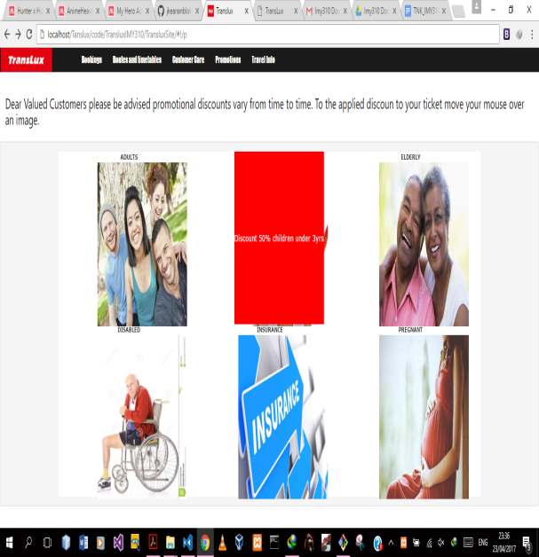

**Description:**

Once the user hovers the cursor over the image depending on who they are buying the ticket for it displays the discount being applied to the passenger. When the mouse hovers over the picture it will display the discount applied at that particular age group. This pertains to a large range of specialized users.

## Task 9:

**Demo:**

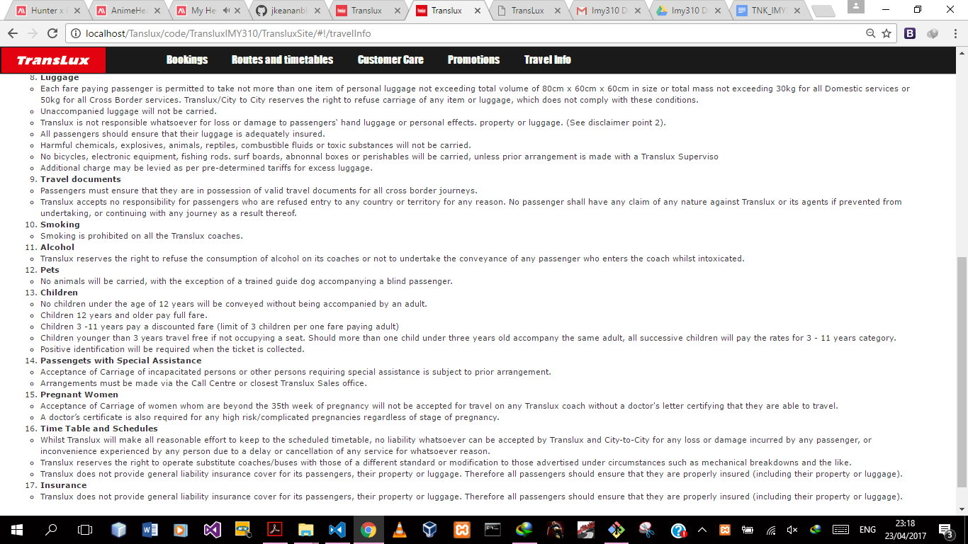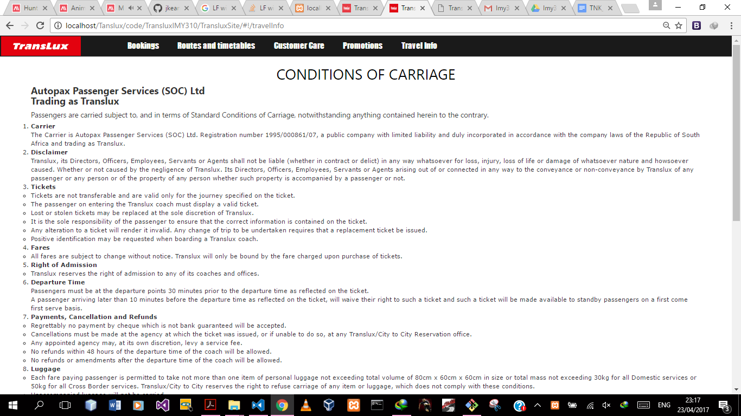

**Description:**

The travel info page informs the users of the bus service the rules they have to abide by when using the transport service provided by Translux. This also helps the user from being negligent with the bus service and making them liable or their own actions. This addresses specialized user needs, particularly legal consultants.

## Task 10:

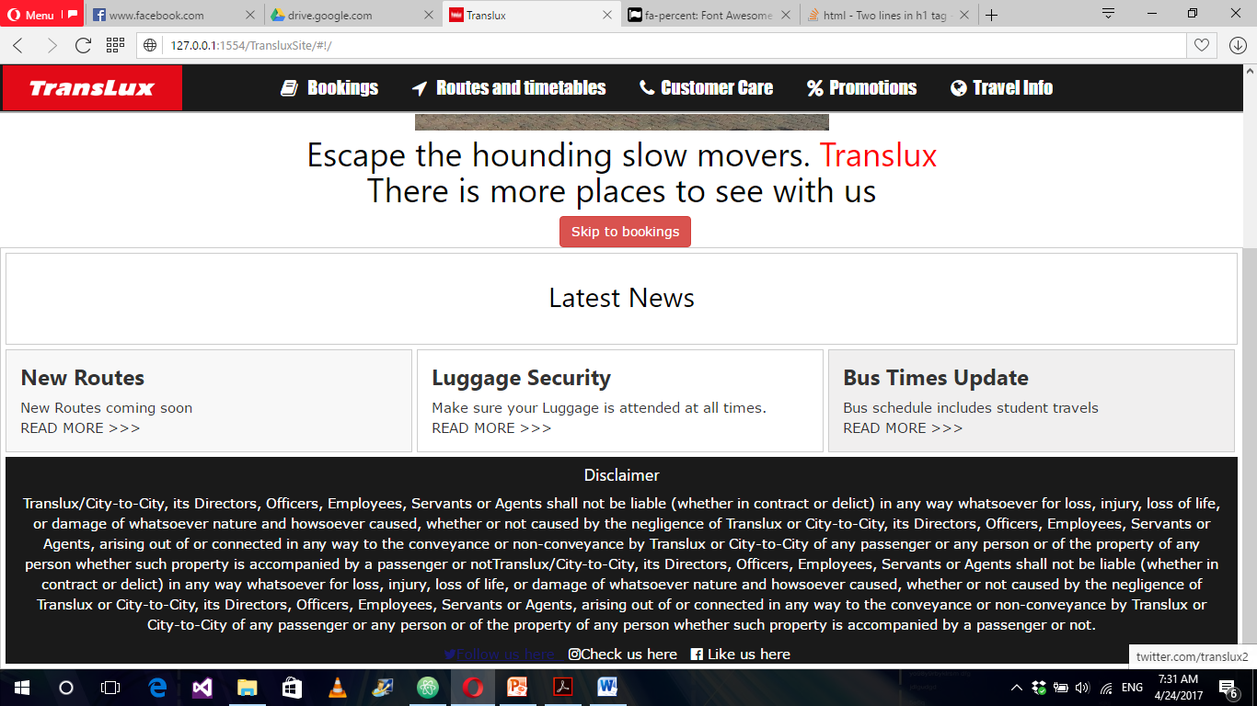**Demo:**

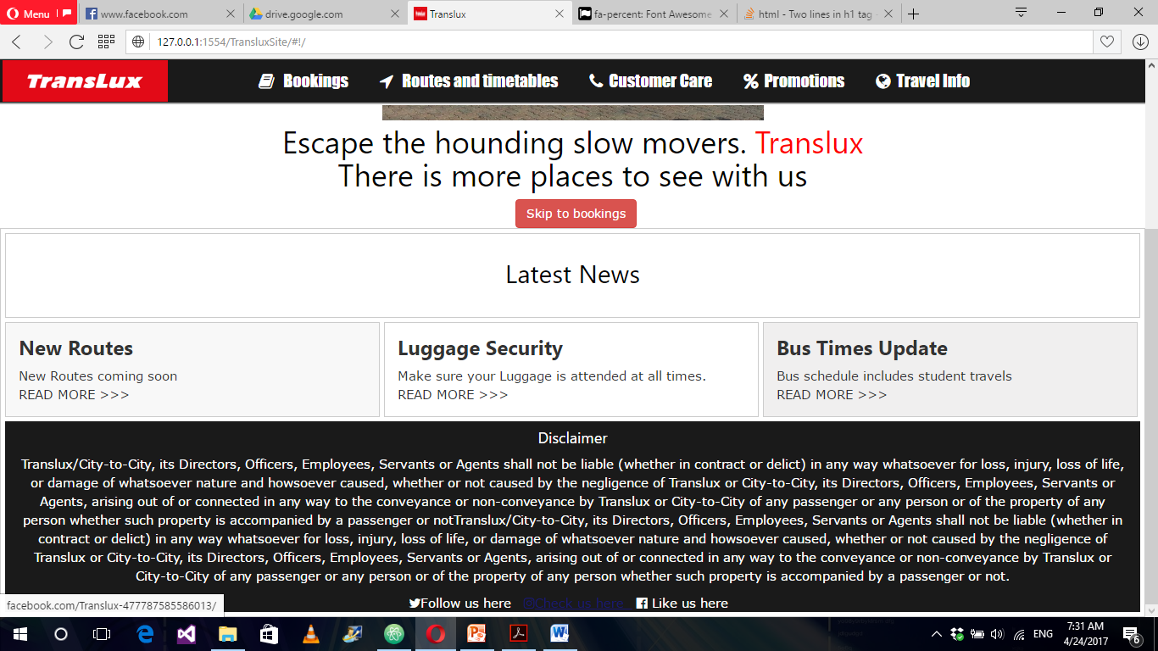

**Description:**

User scrolls down to the footer of the page, and which ever social media the user would like to interact. The link leads to the Translux social media page related to the social media chosen. This addresses the need especially for marketers that like to use the social media to promote the brand and thus is easier to navigate to those pages when using the site.